TITLE

|  |  |
| --- | --- |
| Name Surname*  University of,  City, Country  [mail@domain.com](mailto:mail@domain.com)  Name Surname  University of,  City, Country  [mail@domain.com](mailto:mail@domain.com)  Name Surname  University of,  City, Country  [mail@domain.com](mailto:mail@domain.com)  * corresponding author  *Received*: December, 2021  *1st Revision*: March, 2022  *Accepted*: June, 2022 | **ABSTRACT.** A single paragraph of about 150-200 words maximum. The abstract must be structured (individual parts - titles are bold). We encourage authors to use the following style of structured abstracts without headings: **Background**, **Aims**, **Methods**, **Sample**, **Results**, **Conclusions**, **Implications.**  ***Keywords***: keyword 1, keyword 2, keyword 3 (List three to ten pertinent keywords specific to the article, yet reasonably common within the subject discipline.)  ***JEL Classification****:* example D02, O17, P31  **DOI**: 10.14254/2071-789X.2020/13-1/1 |

Surname, N., & Surname, N. (2020). Title. Journal of Management and Business: Research and Practice, 12(2), 11-25. doi:xx

Introduction

Title references to any material that has been provided by previous authors, or been published in another source should be set according to APA styles (Surname, 2021). We encourage authors to use any citation manager.

Surname (2021) recommends quoting this way if there are multiple authors:

* Surname and Surname (2020) …(Surname & Surname, 2020).
* Surname, Surname, and Surname (2019) …(Surname, Surname, & Surname, 2019).
* Surname et al (2018) …( Surname et al, 2018).

Theoretical background

Each paper must be submitted by e-mail to: jmb@unipo.sk. Submission is completed upon the receipt of a confirmation e-mail.

Methodology

The papers submitted to Journal of Management and Business: Research and Practice should contain results of empirical research and are strictly evaluated in regard to their methodological rigor. The article must provide detailed information on the applied methods. The information on methodology must include:

1. Dates of research (field work) or time period of the analysed data.
2. Data sources used and the empirical research.
3. Description of the data collection methods and source of the data (e.g., national/international official statistics, surveys, interviews, observations, experiments, content analysis etc.).
4. In the case of presentation of survey results: structure of the population, type of the sample, its size and information about its adjustments, as well as sampling error; type of the questions (e.g., open, closed, semi-closed, etc.); authors of methodological tools.
5. Description of the methods of data analysis (e.g., also in the case of basic statistical methods such as estimating correlation coefficients – their statistical dependencies must be indicated; when using factor analysis – the percentage of explained variance has to be provided).
6. Brief summary on the positive and negative aspects of applied methods: testing of methodological tools, difficulties in the implementation of the initial research concept, discovery of the problems with the methodological tools, unpredictable organizational and methodical situations.
7. In the main body of the article the author must directly refer to all tables and figures, for example: “Figure 1 presents the results…”; “The results of the research given in figure 1 indicate…”. When formatting tables one should indicate specific information about the provided data.

Results

Table 1. Title

|  |  |  |  |  |
| --- | --- | --- | --- | --- |
| Var | **Title a** | **Title b** | **Title c** | **Title d** |
| Indicator 1 | 1 | 1 | 1 | 1 |
| Indicator 2 | 2 | 2 | 2 | 2 |

Note: *a: text*

 (1)

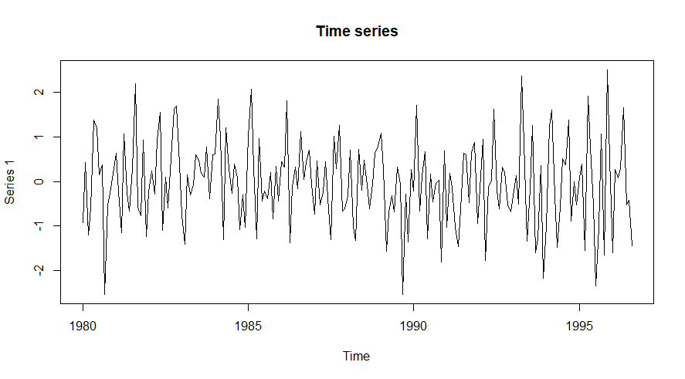

Figure 1. Title

Source: *own data*

Conclusion

The text may contain tables, figures or equations, which should have separate numbering (equations should by typed using the Microsoft Equation 3.0 or Math type). They should be placed in the text at the appropriate paragraph (just after its reference). Please be sure that all imported scanned material is scanned at the appropriate resolution: 1200 dpi for line art, 600 dpi for grayscale and 300 dpi for colour. For more information see the journal template.

Acknowledgement

All sources of funding of the study should be disclosed. Please clearly indicate grants that you have received in support of your research work. Clearly state if you received funds for covering the costs to publish in open access.

References

Surname, A.A. (2021). Title. Journal, 1(1), 1-5. Retrieved from: <https://www.mendeley.com/guides/apa-citation-guide>